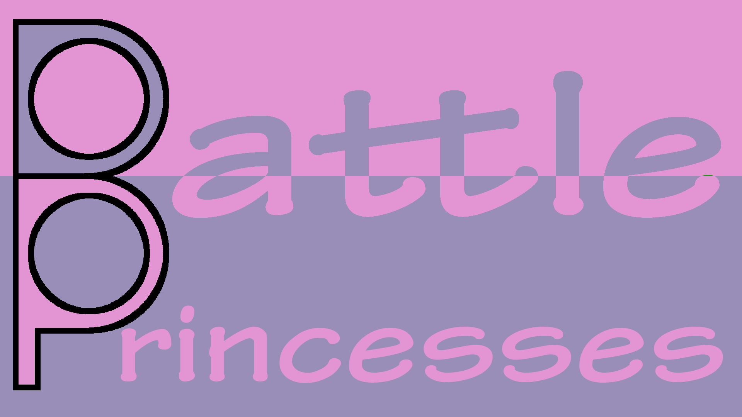

Battle Princesses Rule Set

Table of Contents

1. Setup 3

2. Play 4

3. End Conditions 5

4. Timing Table 5

5. Cards 6

6. Card Types 6

7. Standard Abilities 7

8. Tokens 7

Setup

Each player starts the game with a princess, 5 resouce cards in their starting hand, and 10 point tokens.
Feel free to deal 2 princesses to each player and have them choose 1, or simply choose your favorite.
An additonal 20 points per player is added to a community point pool, along with the crown token.

The marketplace is created based on the number of players:
Number of Players | Stock per Player | Random Stock | (Expanision)  Stock per Player | (Expansion)  Random Stock
2 | 4 | 0 | 5 | 0
3 | 2 | 2 | 3 | 1
4 | 2 | 0 | 2 | 2
5 | 1 | 3 | 2 | 0
6 | 1 | 2 | 1 | 4
7 | 1 | 1 | 1 | 3
8 | 1 | 0 | 1 | 2
9 | 0 | 0 | 1 | 1
10 | 0 | 0 | 1 | 0

Official:
Each player may choose 1 stock from their faction.
The random stocks are chosen from the player factions.
Only 1 of each of the following should be incuded in the marketplace:
Prince, Villain, Location, Item

Alternative 1:
The random stocks are chosen from available non-player factions.

Alternative 2:
Randomly choose stocks from player factions.
Alternative 3:
Randomly choose stock from all available factions.
Alternative 4:
Randomly choose "Stock per Player" from player factions, "Random Stock" from non-player factions.
Play

Check: Determine if the player retains the crown.
If the player with the crown does not have the most points, the crown moves to who does. If players are tied for the most points, then the crown goes to the community pool.
Ready the Princess, if exhausted.

Advance: Flip the player's princess card from Side 1 to Side 2.
If the player has half the number of points to win (1/4 of the total starting points).
If the player chooses to pay 10 resources.
If the player sacrifices 10 points.

Play:
Play cards to the field.
Exhaust cards to resolve their effects. (Including princesses)
Items require a character to exhaust them.
Buy cards from the marketplace. Players get a 1 resource discount on their own faction cards in the marketplace.
A player can can buy 1 scoring point at a cost of 10 resources.
Assault:
Attack power can be spent against other players.
Defense:
Defense power can be used to negate attack power.
Prevent powers can also be used on attacking (or stealing) characters.
Resolution:
For each point of attack power remaining, the attacking player gains 1 socring point from the community pool. If the community pool is empty, then the attacking player may take scoring points from the defending player. If the defending has no scoring points, then no points are awarded for the attack.
Clean:
Discard any exhausted cards in play. (Except Princesses)
Remove any cards that used its last wish token from play.

Fizzle:
Choice any cards in hand to discard.
Draw cards until the player has 5 cards.

End of round:
If the last player to go in a round reaches end of turn and the crown is in the community pool, the crown goes to the player with the most points, unless 2 or more players are tied for the most points.

End Conditions

Scenario 1, Majority Holdings:
At end of round, the player that has more than half of the available points.

Scenario 2, Last Queen Standing:
At end of round, if only 1 player has any points left, that player wins.

Scenario 3, Economic Collapse:
When half of the marketplace stocks are empty, the game ends immediately. The player with the most points wins.

Timing Table
Number of Players | Half Winning Points | Winning Points | Total Points
2 | 17.5 | 36 | 70
3 | 25 | 51 | 100
4 | 32.5 | 66 | 130
5 | 40 | 81 | 160
6 | 47.5 | 96 | 190
7 | 55 | 111 | 220
8 | 62.5 | 126 | 250
9 | 70 | 141 | 280
10 | 77.5 | 156 | 310

Cards

Cards are always played to the field of the player and are either exhausted or require a very specific payment to use its ability. At end of turn, exhausted cards are cleaned into the discard pile. A player may choose whether or not to discard cards in hand.

Types:
Princess: Permanent card, never discard. A kill instead exhausts it.
Resource: Produces resource to buy more cards.
Prince: A special type of character.
Villain: A special type of character.
Location: Can be exhausted like a character, but cannot use items.
Item: Cannot be exhausted without an associated character. If an item's ability matches the character exhausting it, then combine those bonuses.
Character: Can be exhausted to perform abilities and/or use items.

Factions:
Each card is related to a specific princess.
That a player with a princess of a matching faction may buy cards from that faction at 1 less resource.

Blocking:
Some card types can be exhausted to prevent others from being effective.
This can be done during a player's turn, or while defending. It can even be done in reaction, as long as the counter card was not the original target.

Card Types

Any character, to include Princes, Villains, and Princesses can be used to exhaust and item.
Card Type | Counters Card Type
Prince | Villain
Villain | Item
Item | Location
Location | Prince

Standard Abilities

Attack: Supply 1 strength against another kingdom, will take 1 point from the defending kingdom if not blocked, discarded or removed.
Defense: Supply 1 strength against an attacking kingdom, compare attacking strength to defending strength.
Prevent: Prevent that number of characters from attacking or stealing.
Steal: Will transfer points without attacking.
Stun: A character gains stun tokens and cannot be used while stunned.
Kill: Discard that number of characters from the board.
Poison: A character gains poison tokens and is trashed when the counters run out. A character with poison counters cannot gain more.
Stop: Prevent a character from activating until the following round.
Turn: Recruit a character from another kingdom to your kingdom.
Resource: Generates that much resource.
Starve: Prevents that much resource from being uses and is then discarded.
Score: Take a point from the Pooled points.
Wish: A character gains wish tokens.

Tokens

Crown: Worth 10 points. Can be used in the same manner as an item to steal one point from another player. Only usuable by a princess.
Score: Worth 1 point.
Wish: A wish token can be removed to perform the following:
Stun
Steal
Stop
Turn
Prevent
Score
Cast a character without paying its cost
Buy a card without paying its cost
Pay for an ability without paying its cost
Remove a status effect

